**SRI SHANMUGHA COLLEGE OF ENGINEERING AND TECHNOLOGY**

**Department of Biomedical Engineering**

**SMART PARKING**

**Phase 3 Submission Document**

**Team members**

S. Swetha- (732721121055)  
 M. Sindhu - (732721121046)  
 T. Srimathi- (732721121051)  
 C. Chanthruba- (732721121007)

R. Bharathi- (732721121006)



**Introduction:**

The goal of parking system project is to reserve parking spot for a car/vehicle before it arrives. One of the most problems that the driver faces is finding a free parking spot, so many driver stopping their cars at the edges of the street. Therefore, we choose this to prevent the frustration of finding a parking spot and they can reserve a spot when they stay at home. It is an IOT based project.

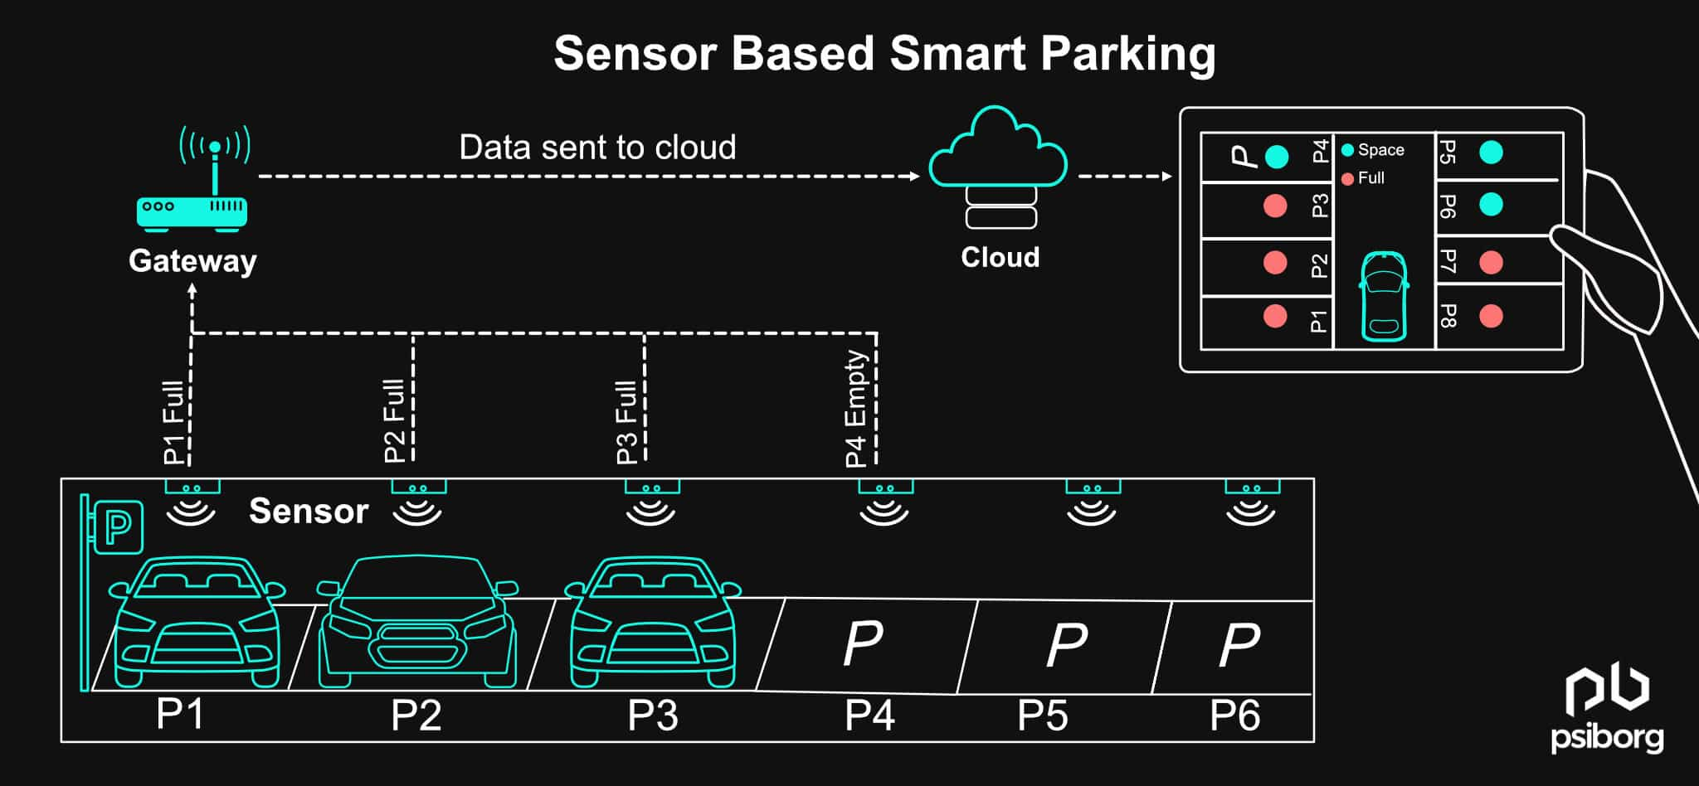

**Overview of the process:**

Smart parking systems aim to improve the efficiency and convenience of parking by leveraging technology and data to assist drivers in finding available parking spaces. The process of a typical smart parking system involves several key components and steps:

**Sensor Deployment**: Sensors, such as ultrasonic sensors, infrared sensors, or cameras, are installed in parking spaces or areas to monitor their occupancy status. These sensors can detect whether a parking spot is vacant or occupied.

**Data Collection:** The deployed sensors continuously collect data on the availability of parking spaces. This data is sent to a central server or cloud-based platform for processing and analysis.

**Data Processing and Analysis**: The data collected from sensors is processed and analyzed in real-time to determine the availability of parking spaces. Machine learning algorithms may be used to predict parking spot availability based on historical data and real-time sensor readings.

**User Interface:** A user-friendly interface, often in the form of a mobile app or a website, is made available to drivers. This interface provides real-time information about parking availability, including the number of available spots and their locations.

**Navigation and Booking:** Drivers can use the app or website to search for available parking spots near their destination. The system provides navigation instructions to guide drivers to the selected parking spot. Some systems also allow users to reserve parking spaces in advance.

**Payment and Billing:** Payment for parking can be integrated into the app or website. Drivers can make payments electronically, reducing the need for physical tickets or cash. Parking fees can be automatically calculated based on the duration of the stay.

**Feedback and Alerts:** The system can provide alerts to drivers, such as reminders of when their parking time is about to expire. Drivers can also provide feedback on the parking experience, helping operators improve the system.

**Management and Analytics:** Operators of the smart parking system have access to a management dashboard where they can monitor the status of parking spaces, gather analytics, and make data-driven decisions to optimize parking operations.

**Integration:** Smart parking systems can be integrated with other urban infrastructure systems, such as traffic management and public transportation, to create a more holistic approach to urban mobility.

**IOT Sensors:**

IoT, or the Internet of Things, refers to the interconnected network of physical devices and objects that are embedded with sensors, software, and other technologies, enabling them to collect and exchange data with other devices and systems over the internet. IoT sensors are a fundamental component of this ecosystem, as they are the devices responsible for capturing and measuring data from the physical world. These sensors are designed to monitor various aspects of the environment, such as temperature, humidity, light, motion, sound, pressure, and more. The data collected by these sensors is then transmitted to IoT platforms or systems for analysis, storage, and decision-making.

**1)Ultrasonic Sensor:**

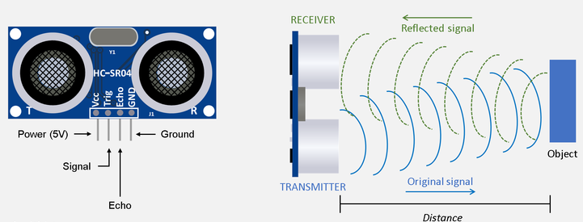 An ultrasonic sensor is a type of sensor that uses high-frequency sound waves (ultrasonic waves) to detect and measure the distance to objects in its vicinity. These sensors are commonly used for proximity sensing, object detection, and distance measurement in various applications.

Ultrasonic sensors are commonly used in a variety of applications, including robotics, automotive parking assistance systems, industrial automation, and even in some consumer electronics for touchless user interfaces. They are preferred for their non-contact nature, accuracy, and reliability in measuring distances.

**2)IR Sensor:**

An IR sensor, or infrared sensor, is a type of electronic device that is designed to detect and respond to infrared (IR) radiation. Infrared radiation is part of the electromagnetic spectrum and consists of wavelengths longer than those of visible light. IR sensors are used for a wide range of applications, including remote controls, motion detection, object detection, and temperature measurement.

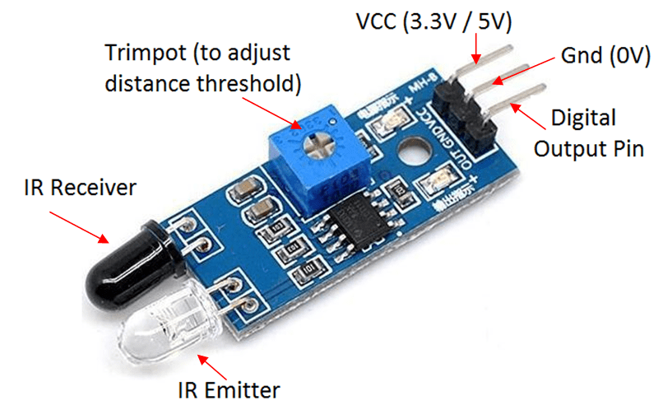

IR sensors are popular due to their non-contact nature and ability to work in various lighting conditions. They operate in the infrared spectrum, which is invisible to the human eye. Depending on their specific design and purpose, IR sensors can detect heat, motion, or the presence of objects, making them valuable components in numerous consumer electronics, industrial automation, and security systems.

**Sensors and Raspberry pi integration:**

A Raspberry Pi is a series of small, affordable, single-board computers developed by the Raspberry Pi Foundation. These computers are designed for educational purposes, hobbyist projects, and various practical applications. Raspberry Pi boards are credit-card-sized, and they come equipped with the essential components required for basic computing, including a CPU, RAM, storage, input/output ports, and support for various operating systems.

The Raspberry Pi has had a significant impact on the world of computing and education due to its affordability and versatility, making it a popular choice for a wide range of projects and applications.

Interfacing sensors with a Raspberry Pi involves connecting sensors to the Raspberry Pi's GPIO (General-Purpose Input/Output) pins and then using programming and appropriate libraries to read data from these sensors.

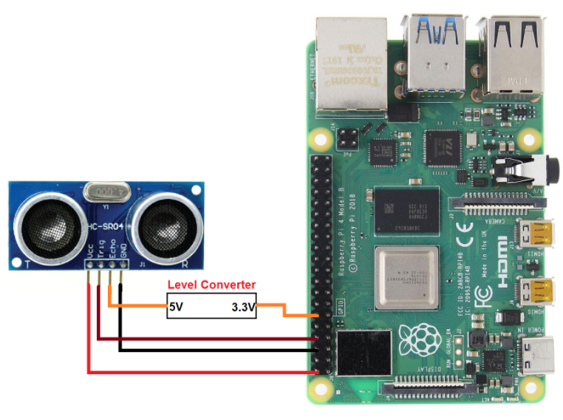 **Model:**

Creating a smart parking system using a Raspberry Pi involves combining hardware components, such as sensors and cameras, with software to monitor and manage parking spaces efficiently.

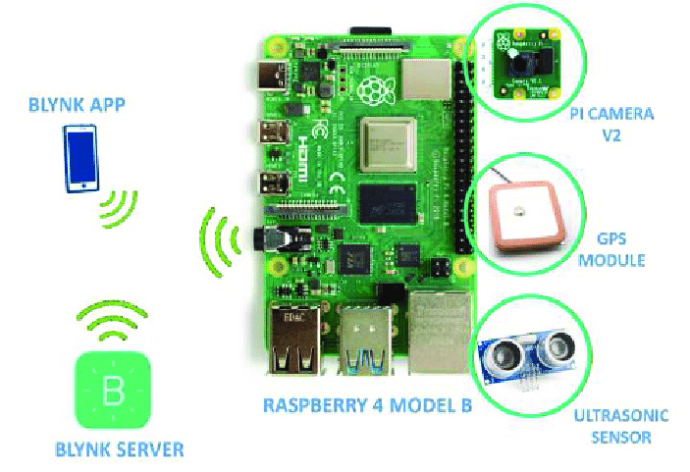

**Steps to Create a Smart Parking System**:

**Sensor Setup:** Connect the ultrasonic sensors to the Raspberry Pi's GPIO pins. Write a Python script to read data from the sensors and detect the presence of vehicles. You can use libraries like RPi.GPIO or GPIO Zero to interface with the sensors.

**Camera Setup:** Configure the Raspberry Pi camera module. You can use the Pi Camera's Python library to capture images or record video. Take snapshots or short videos periodically to monitor the parking area.

**Data Processing:** Process the sensor data to determine if parking spaces are occupied or vacant. Combine sensor data with camera data for visual verification.

**Display or Indication:** Use LEDs or an LCD display to show the real-time status of parking spaces.Update the display based on sensor data, indicating which spaces are available and which are occupied.

**User Interface:** Create a user interface, which could be a web application, mobile app, or a simple website, to allow users to check parking space availability remotely.

**Data Storage:** Store historical data, which can be helpful for analytics, in a database. SQLite or MySQL can be used for this purpose.

**Alerts and Notifications:** Implement a notification system to alert users when a parking space becomes available or if there are issues in the parking area.

**Security and Authentication:** Add security measures to protect the system from unauthorized access.Implement user authentication if necessary for the user interface.

**Testing and Calibration:**Test the system extensively to ensure accurate parking space detection.Calibrate the sensors and camera for optimal performance.

**Deployment:** Install the system in the parking area and ensure a reliable power source for the Raspberry Pi.

**Monitoring and Maintenance:** Regularly monitor the system's performance and perform maintenance as needed.Address any hardware or software issues promptly.

**Python scripts on Raspberry Pi:**

import RPi.GPIO as GPIO

import time

# Set GPIO pins

trigger_pin = 18

echo_pin = 17

# Set GPIO mode

GPIO.setmode(GPIO.BCM)

# Setup GPIO pins

GPIO.setup(trigger_pin, GPIO.OUT)

GPIO.setup(echo_pin, GPIO.IN)

try:

while True:

# Send a trigger pulse

GPIO.output(trigger_pin, True)

time.sleep(0.00001)

GPIO.output(trigger_pin, False)

pulse_start = time.time()

while GPIO.input(echo_pin) == 0:

pulse_start = time.time()

pulse_end = time.time()

while GPIO.input(echo_pin) == 1:

pulse_end = time.time()

pulse_duration = pulse_end - pulse_start

distance = pulse_duration * 17150 # Speed of sound = 343 m/s (17150 cm/s)

# Check if a car is present based on distance

if distance < 10: # Adjust this value based on your parking space layout

print("Parking space is occupied")

else:

print("Parking space is vacant")

time.sleep(1) # Check the status periodically

except KeyboardInterrupt:

GPIO.cleanup()

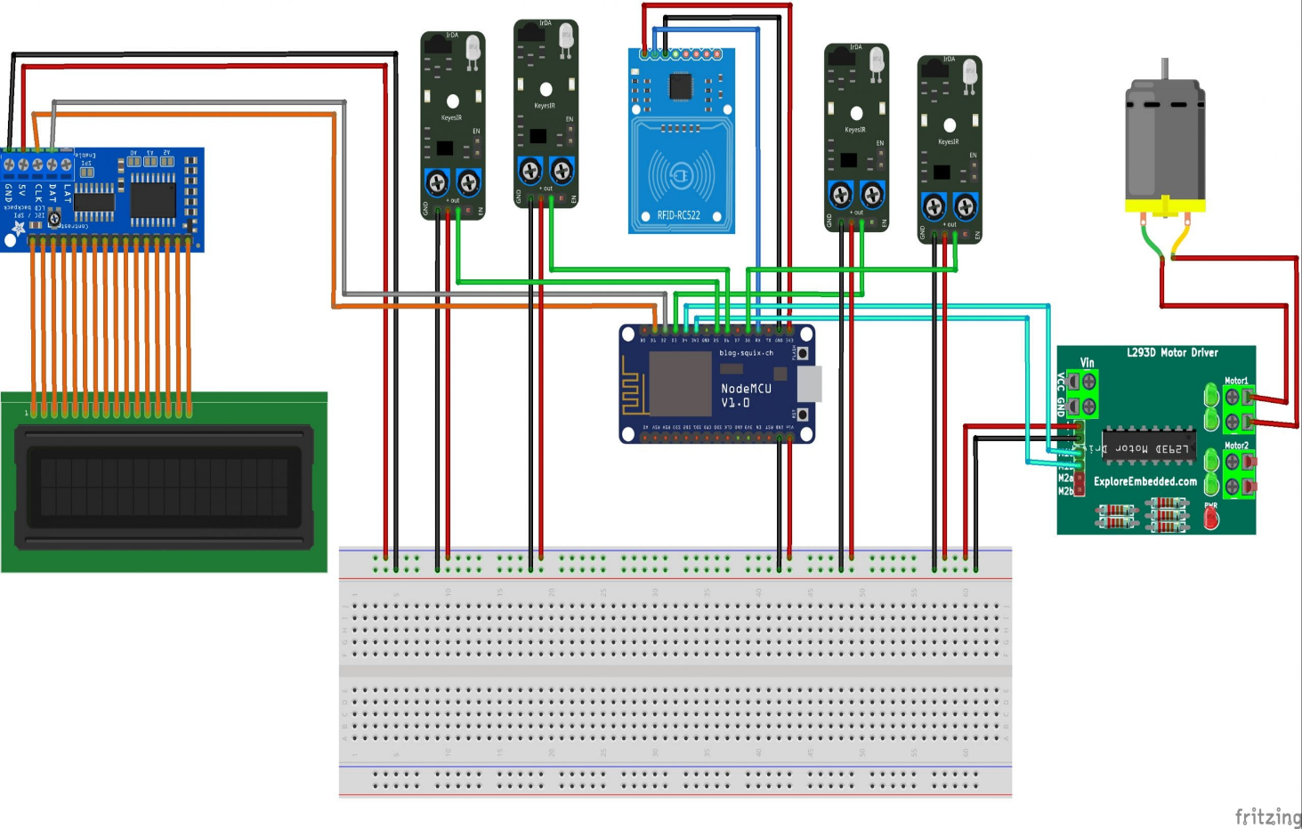**Simulation of the system:**



**Working:**



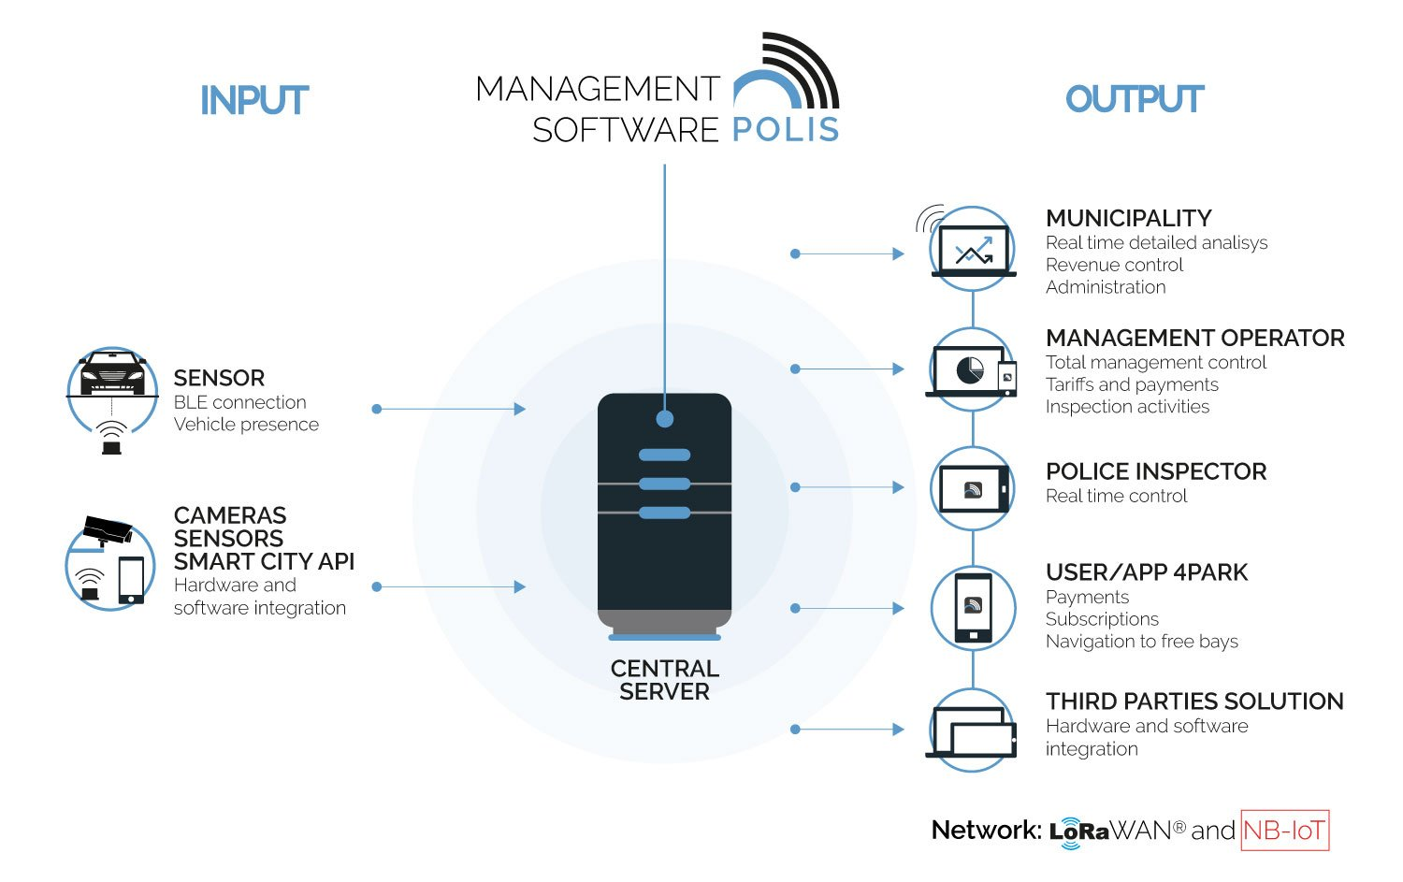



**Mobile application:**

**Blynk App**

Blynk is a popular mobile app and cloud-based platform designed for Internet of Things (IoT) and home automation projects. Blynk allows users to create custom interfaces and control IoT devices and projects using their smartphones or tablets. It simplifies the process of building IoT applications by providing a user-friendly interface and easy integration with a wide range of hardware devices and platforms.

Blynk is widely used by IoT enthusiasts, makers, and developers to create various projects, such as home automation, remote monitoring, smart devices, and more. It simplifies the development process by providing a versatile platform for creating custom mobile interfaces and connecting them to a wide range of hardware devices and sensors.

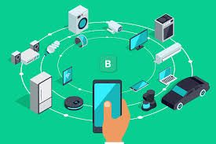

**Conclusion:**

Smart parking solutions offer a comprehensive approach to tackling the challenges associated with parking in today's urban environments. While initial implementation can be an investment, the long-term benefits in terms of reduced traffic congestion, environmental impact, and improved user experiences make smart parking a valuable addition to modern cities. As technology continues to advance, smart parking systems are likely to evolve and become even more integral to urban planning and sustainability efforts.